Chapter 6: FINANCIAL ACCOUNTING

The Balance Sheet
Definition
- Shows what the company owns (assets) and owes (liabilities) at a given point in time

Key Terms
- Current Assets – assets likely to be converted into cash within a year
  - Example: cash, accounts receivable, inventory
- Fixed Assets – long-term assets used in business
  - Example: land, buildings, machinery
- Depreciation – reduction in value of fixed assets over time
  - Example: machinery losing value after 5 years
- Tangible Assets – physical assets
  - Example: computers, vehicles
- Intangible Assets – non-physical assets
  - Example: patents, software licenses
- Current Liabilities – debts payable within a year
  - Example: short-term loans, accounts payable
- Fixed Liabilities – long-term debts
  - Example: bank loans, bonds

Example / Case
- A startup owns office computers ($10,000), cash ($5,000), owes short-term suppliers ($3,000), and a long-term bank loan ($15,000).
  - Assets: $15,000
  - Liabilities: $18,000

The Balance Sheet Example
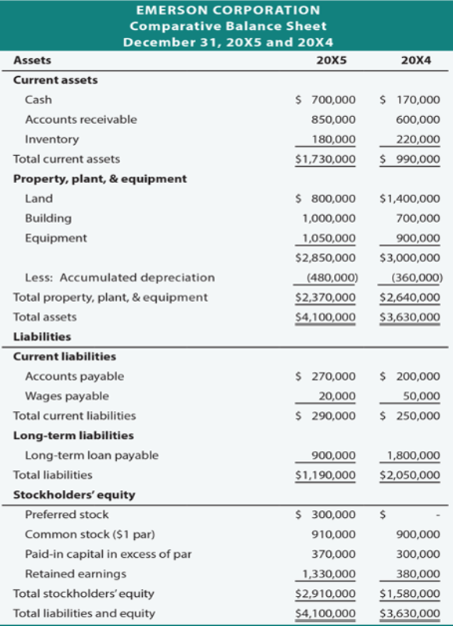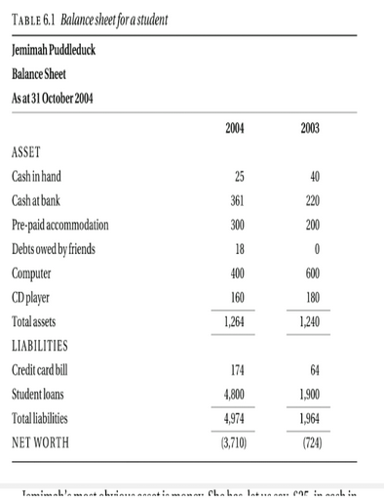

The Profit and Loss Account (P&L)
Definition
- Shows how much money the company has received (income) and spent (expenses) over a specific period, usually a financial year.
- For non-profit organizations, it is called the Income and Expenditure Account.
Purpose
- Measures financial performance of the business
- Helps determine profit or loss for the period
Example / Case
- A software company earns $50,000 from services and spends $35,000 on salaries, rent, and utilities:
  - Profit: $15,000
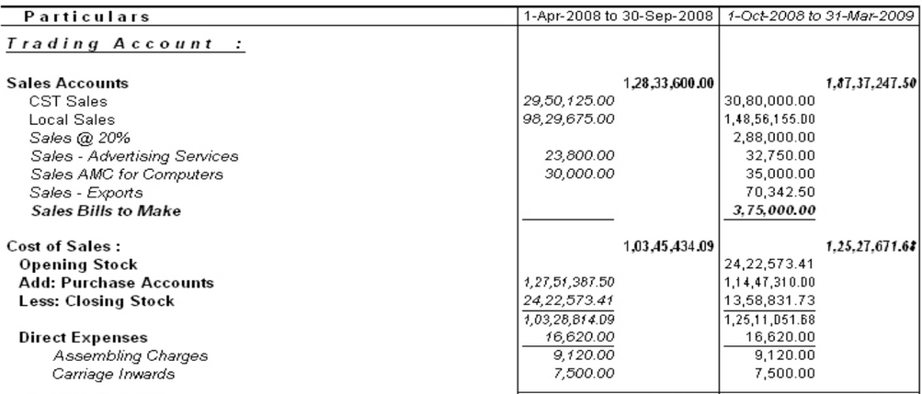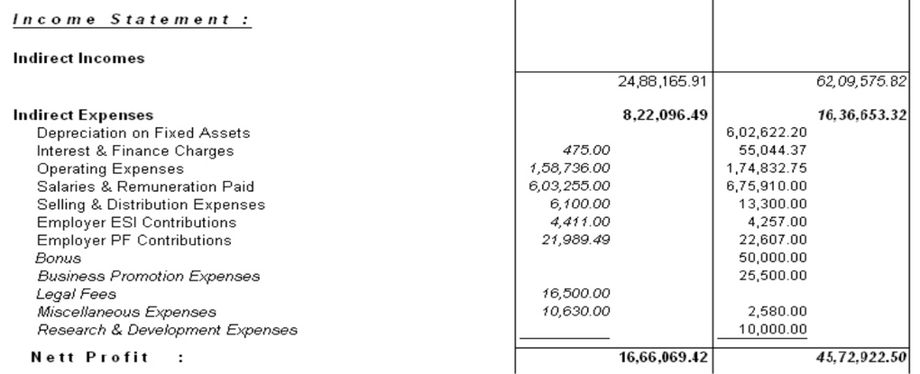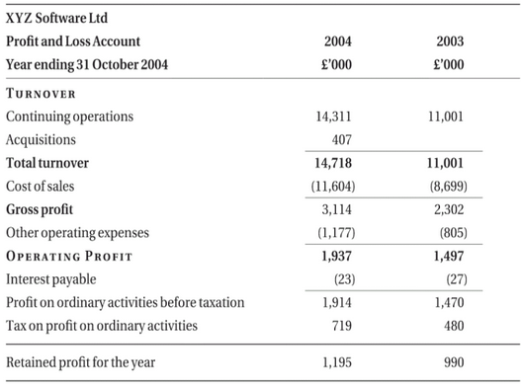

Income Expenditure Account
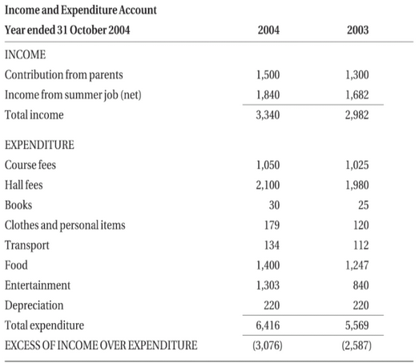

Cash Flow Statement
Definition
- Shows the movement of cash in and out of the company during a specific period
- Links the Balance Sheet and Profit & Loss Account to capital expenditure
Purpose
- Tracks sources and uses of cash
- Helps understand liquidity and how money is spent or received
Example / Case
- A company earns $50,000 revenue, pays $20,000 in salaries, $5,000 for equipment, and invests $10,000 in marketing:
  - Cash inflow: $50,000
  - Cash outflow: $35,000
  - Net cash flow: $15,000
Analogy
- Like parents asking children “where the money came from and where it went”, a cash flow statement shows the flow of money in the business.
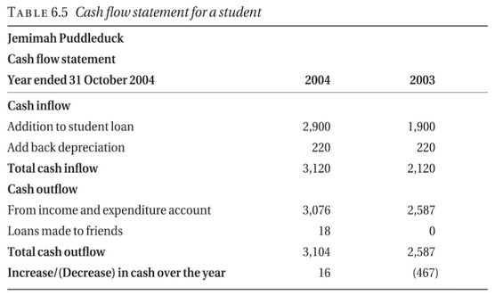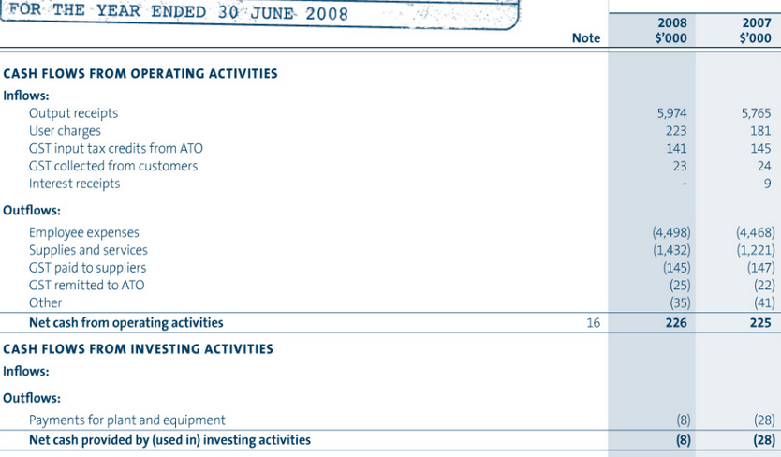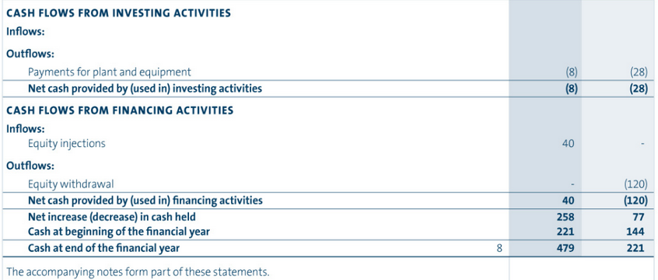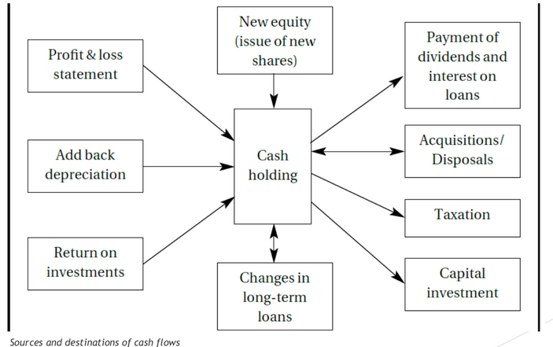

Relation between them all
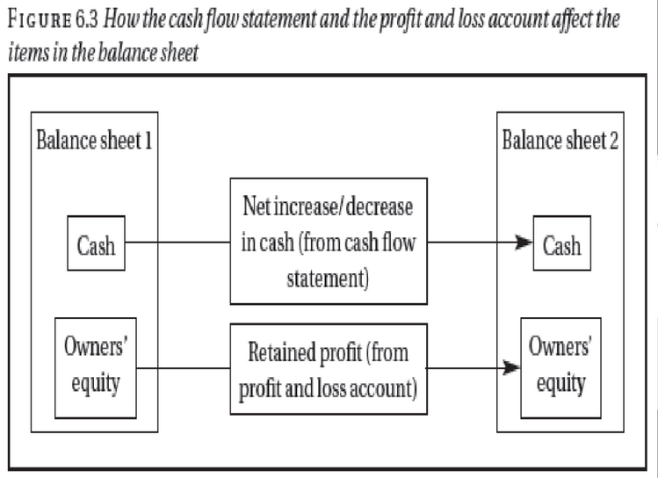
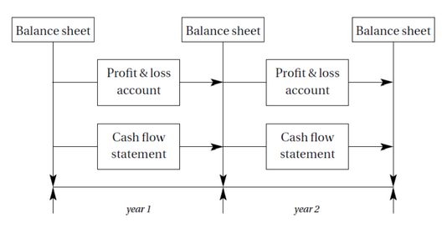

Chapter 6: SOLVED NUMERICAL
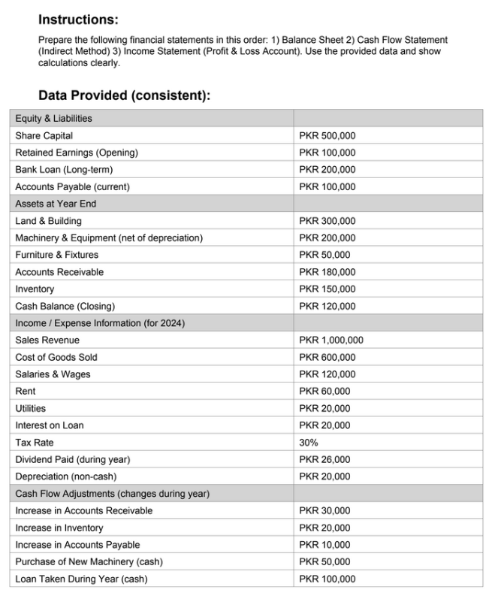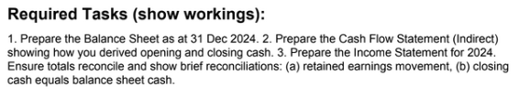

Answer:
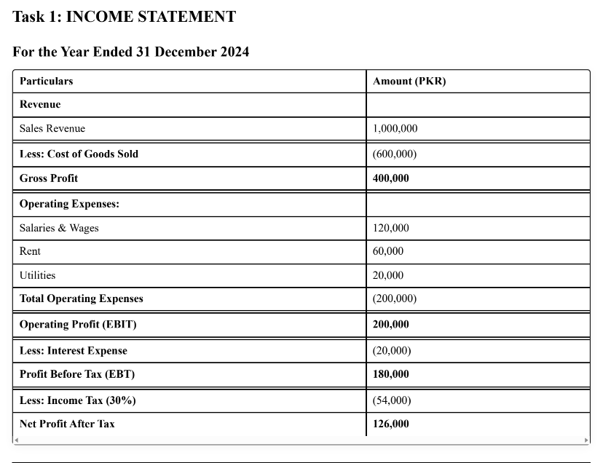
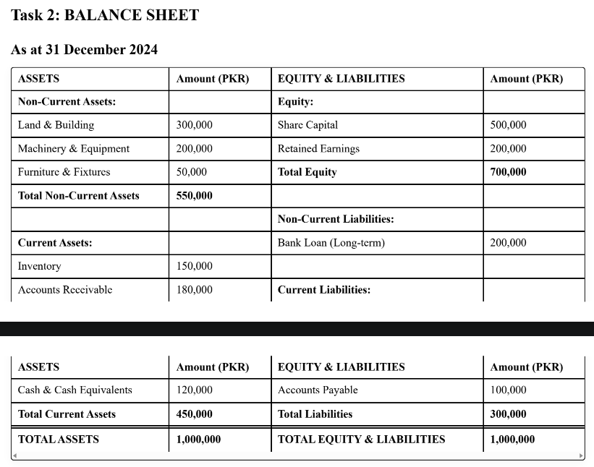
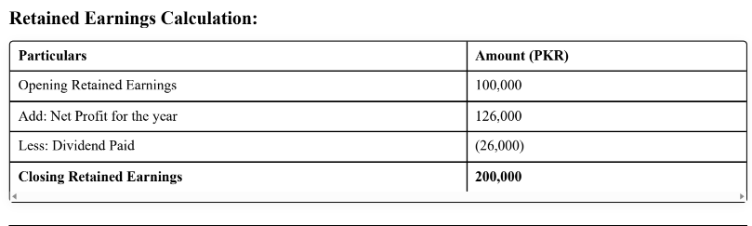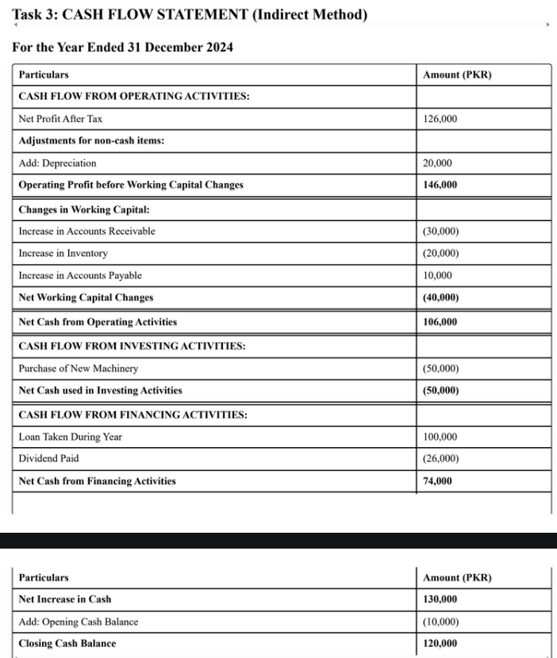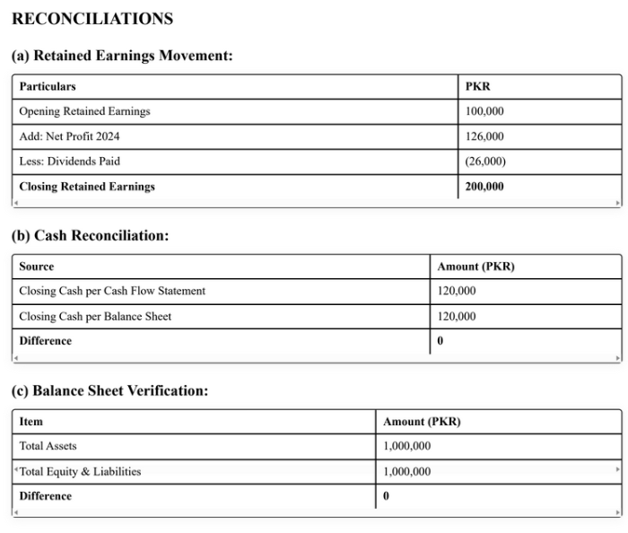

Chapter 6: MID 2 Solved Numerical For Cash Flow, Income Statement
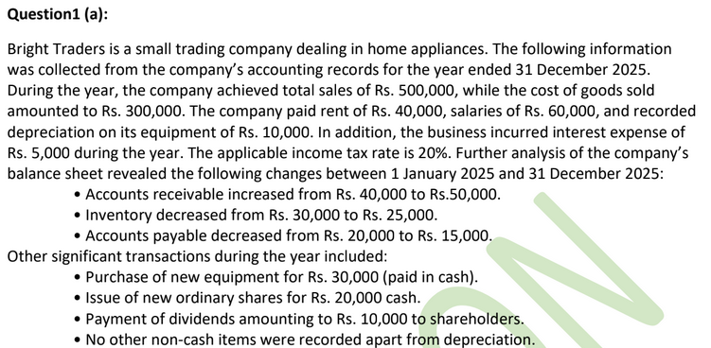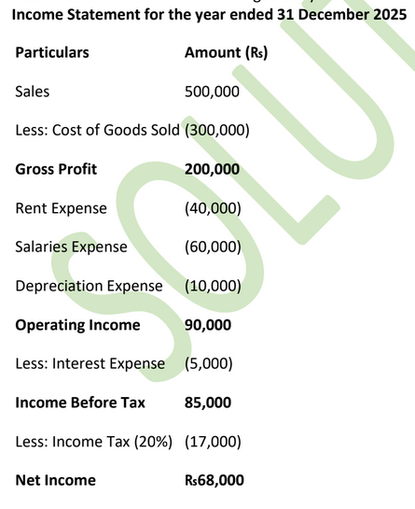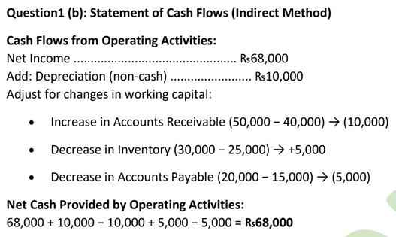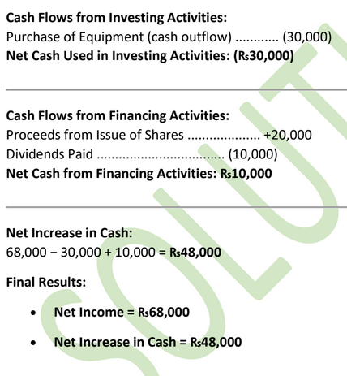

Chapter 7: MANAGEMENT ACCOUNTING

Cost of Labour
The cost of labour is the total expense incurred by an organization in employing a worker. It is not limited to the employee’s salary.
In most countries, employers are legally required to pay additional taxes or contributions for each employee. These may include:
- Employer’s National Insurance (UK)
- Social Security contributions
- Pension contributions or other statutory benefits
These contributions are usually calculated as a percentage of the employee’s salary.
In some countries, this percentage can be as high as 60% of the salary, while in others it may be significantly lower.

Formula:
Cost of Labour = Salary + Employer Contributions

Example:
If an employee earns 50,000 and the employer contribution is 20%:
Employer contribution = 10,000
Total cost of labour = 60,000
This total cost is used in costing, budgeting, and pricing decisions, not just the salary amount.

Overheads
Overheads are costs that cannot be directly linked to a specific product or service but are necessary for the overall operation of the business.

Examples of Overheads:
- Rent of office or factory
- Electricity and water
- Internet and telephone
- Administrative staff salaries
- Equipment depreciation
- Maintenance and security
Since overheads are indirect costs, they are usually shared or distributed across products or services using appropriate methods.
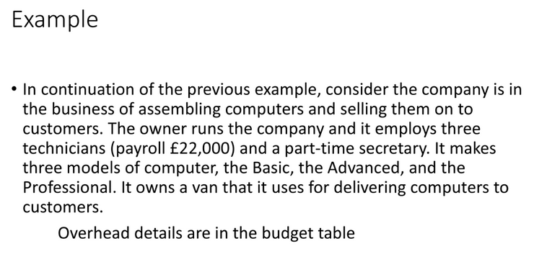
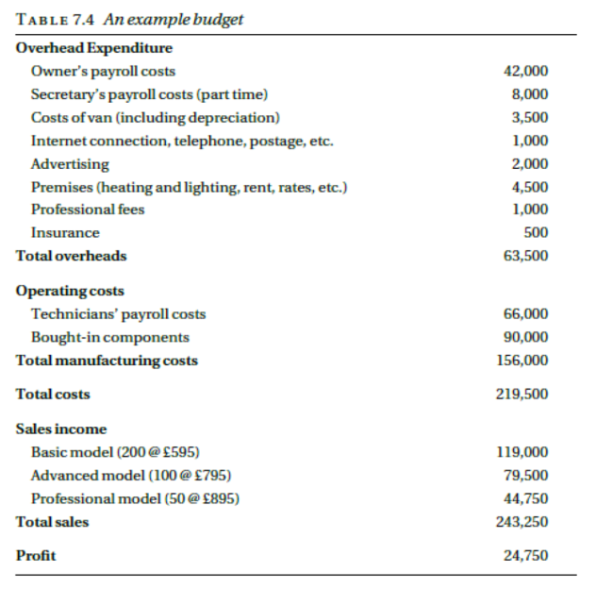
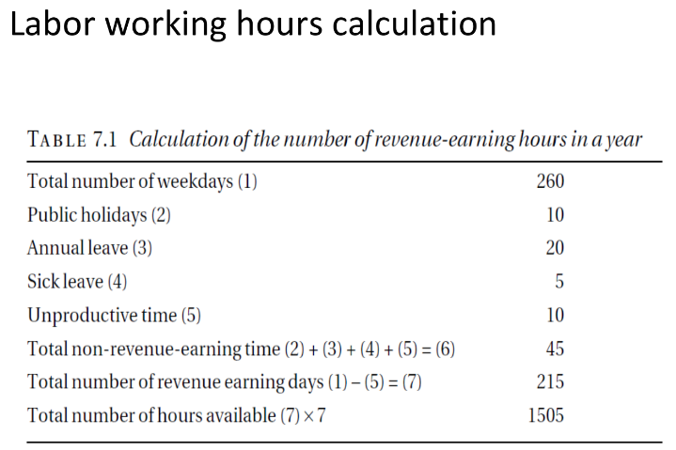

PAYROLL (DIRECT LABOUR COST)
Definition:
Payroll (also called direct cost) is the total cost of employing an employee, not just their salary.
What Payroll Includes:
- Employee’s basic salary
- Employer’s social security contributions
- Any other costs directly related to employing that person
Key Idea:
Payroll cost reflects what the employee actually costs the company, not what they receive.
Example:
A technician earns a salary of £20,000 per year.
After adding employer contributions and related costs:
- Payroll cost = £22,000 per year
This £22,000 is the true cost of employing the technician.

DIRECT COST PER HOUR
Concept:
To calculate the cost of one hour of labor, divide annual payroll cost by total working hours per year.
Formula:
Direct cost per hour = Payroll cost / Annual labor hours
Given:
- Payroll cost = £22,000
- Annual working hours = 1,505
Calculation:
£22,000 / 1,505 = £14.62 per hour
Interpretation:
Every hour the technician works costs the company £14.62.
Example:
If the technician works 10 hours on a task:
- Labor cost = 10 × £14.62 = £146.20

COST OF LABOUR IN PRODUCT CONSTRUCTION
Important Point:
Labor cost is not the only cost involved. Even a single technician has additional costs such as:
- Equipment
- Software
- Setup and configuration time
Scenario:
- Computer hardware cost = £200
- Assembly + installation time = 10 hours
- Hourly labor cost = £14.62
Calculation:
Total cost = £200 + (10 × £14.62)
Total cost = £346.20
Meaning:
The final product cost includes both material cost and labor cost.

EXAMPLE 1 – OVERHEAD COSTING
Given Data:
- Total overhead cost = £63,500
- Number of technicians = 3
- Payroll per technician = £22,000
- Labor hours per technician = 1,505
- Expected sales = 350 units
Hourly labor cost:
£22,000 / 1,505 = £14.62
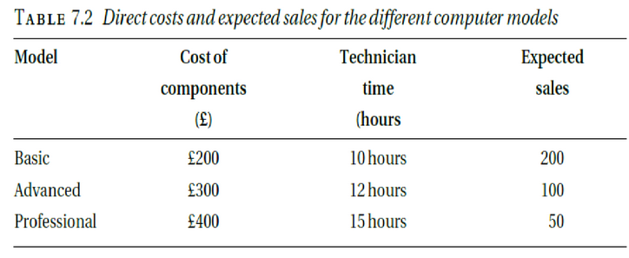

METHOD 1: FIXED OVERHEAD PER UNIT
Concept:
Overhead is spread equally across all units expected to be sold.
Calculation:
Overhead per unit = £63,500 / 350 = £181.43
Cost Calculations:
- Basic model:
£181.43 + £200 + (10 × £14.62) = £527.63
- Advanced model:
£181.43 + £300 + (12 × £14.62) = £651.83
- Professional model:
£181.43 + £400 + (15 × £14.62) = £802.23
Interpretation:
Each unit carries the same overhead, regardless of complexity.

METHOD 2: OVERHEAD PROPORTIONAL TO LABOUR
Concept:
Overhead is allocated based on the number of labor hours used.
Calculation:
Total labor hours = 3 × 1,505
Overhead per labor hour = £63,500 / (3 × 1,505) = £14.06
New hourly labor cost:
£14.62 + £14.06 = £28.68 per hour
Cost Calculations:
- Basic model:
£200 + (10 × £28.68) = £486.80
- Advanced model:
£300 + (12 × £28.68) = £644.16
- Professional model:
£400 + (15 × £28.68) = £830.20
Interpretation:
Products requiring more labor absorb more overhead.

METHOD 3: OVERHEAD PROPORTIONAL TO TOTAL DIRECT COST
Concept:
Overhead is applied as a percentage of the total direct cost of all expected sales.
Direct Cost per Unit:
- Basic model = £346.20
- Advanced model = £475.44
- Professional model = £619.30
Sales Volume:
- Basic: 200 units
- Advanced: 100 units
- Professional: 50 units
Overhead Percentage Calculation:
£63,500 / (200×346.20 + 100×475.44 + 50×619.30) = 0.43 (43%)
Overhead Factor:
1 + 0.43 = 1.43
Final Costs:
- Basic model:
£346.20 × 1.43 = £495.06
- Advanced model:
£679.88
- Professional model:
£885.60
Interpretation:
More expensive products absorb a higher share of overhead.
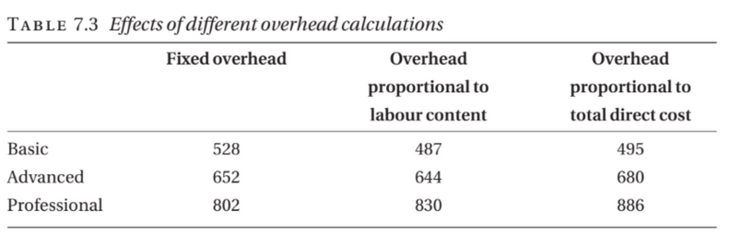

BUDGETING & CASH FLOW FORECAST – Professional Notes

1. Budgeting
Definition:
A budget is a financial plan showing the expected income and expenditure for an organization over a specific period, usually one year.

Key Points
- Owner’s Salary:
  - Owners should treat themselves as employees and pay a salary instead of living off profits.
  - Ensures proper taxation, social security contributions, and realistic business costs.
  - Example: Owner’s payroll costs = $3,000/month → $36,000/year.
- Professional Fees:
  - Businesses often require accountants for annual accounts and occasional advice.
  - Lawyers may also be needed for legal guidance.
  - Example: Accountant fees = $1,500/year; Legal fees = $1,000/year.
- Insurance:
  - Employers must legally carry insurance for employee injuries.
  - Additional insurance may cover theft, fire, or property damage.
  - Example: Employee liability insurance = $2,000/year; Theft insurance = $500/year.
Purpose of Budgeting:
- Ensures financial planning for income and expenditure.
- Helps control spending, plan for salaries, fees, and insurance.
- Useful for decision-making and obtaining finance.

2. Cash Flow Forecast
Definition:
A cash flow forecast is an estimate of money flowing in and out of a company each month, usually for 12 months, to ensure bills can be paid on time.

Key Points
- Importance:
  - A business may be profitable but still unable to pay bills if cash inflows and outflows are mismatched.
  - Staff salaries and other obligations must be met before income is received.
  - Failure to manage cash flow can lead to receivership.
- Forecasting:
  - Estimates monthly cash inflows (sales, investments, loans).
  - Estimates monthly cash outflows (salaries, rent, materials, fees, insurance).
  - Net Cash Flow = Inflows – Outflows
  - Closing Balance = Opening Balance + Net Cash Flow

Example Scenario:
- Opening Cash: $2,000
- Monthly Inflows: $10,000
- Monthly Outflows: $8,500
- Net Cash Flow = $1,500
- Closing Balance = $3,500 → business can pay bills comfortably.
Purpose of Cash Flow Forecast:
- Avoids cash shortages.
- Ensures employees and bills are paid on time.
- Helps plan borrowing or spending.

Chapter 7: Mid 2 Solved Numerical Of Overhead Cost
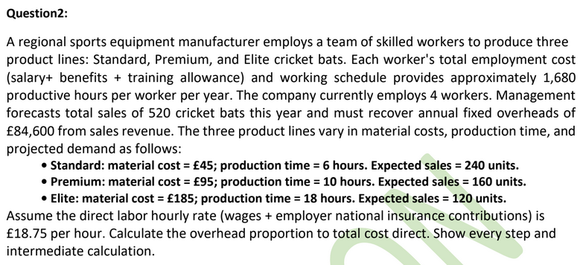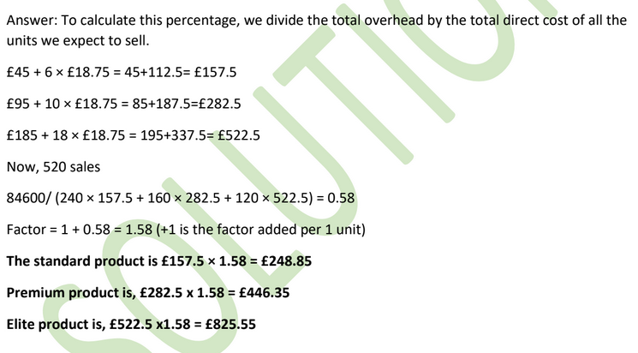

Chapter 8: Investment Appraisal

INVESTMENT APPRAISAL

Introduction

Definition
- Investment appraisal is the analysis of profitability of an investment over the life of an asset.
- Also considers:
  - Affordability
  - Strategic fit with company goals.

Why Needed
- Limited resources + many proposals → must choose the best option.

Factors to Consider
- Fit with long-term plans.
- Risk involved.
- Availability of resources (people, skills, time), not just money.
Example/Case:
- A company chooses between building a new app or upgrading servers based on profit and strategy.

Discounted Cash Flow (DCF)

What is DCF?
- A method to estimate today’s value of an investment based on its future cash flows, adjusted for time.
- Helps decide which proposal gives the best return.

Uses of DCF
- Check if a company’s share price is fair.
- Decide buy vs lease equipment.
- Compare projects.
- Decide if a capital project is worthwhile.
Example/Case:
- Compare two software projects by calculating which has higher present value.

Time Value of Money

Concept
- Money today is worth more than the same money in future.
- Because today’s money can earn interest.

Also Called
- Net Present Value (NPV) concept.
Example:
- Rs. 1,000 today is better than Rs. 1,000 after one year because today’s money can grow.

Discount Factor & Present Value

Formula
If interest rate = r, amount = X, time = t years:
PV=X(1+r)tPV = \frac{X}{(1+r)^t}PV=(1+r)tX​
- Discount factor = 1 / (1 + r)^t

Example
- Discount factor at 8% for 4 years = 0.7350
- Present value of £1,000 after 4 years:
  - £1,000 × 0.7350 = £735
Example/Case:
- Receiving £1,000 in 4 years is equal to £735 today at 8% interest.
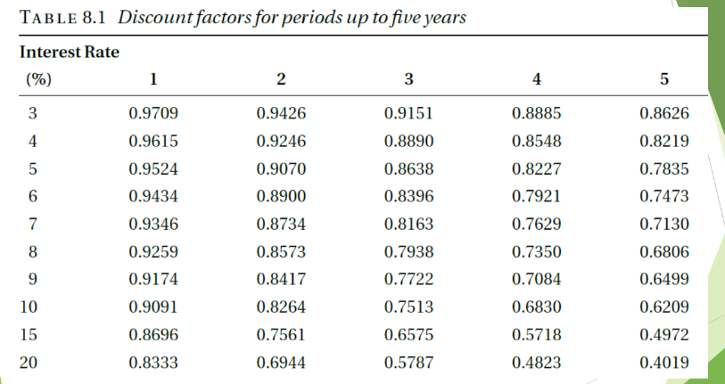

Purchasing vs Leasing (Car Example)

Given
- Car price = Rs. 10,00,000
- Lease:
  - Down payment = Rs. 2,00,000
  - Monthly = Rs. 20,000 for 60 months
Total lease cost:
- (20,000 × 60) + 2,00,000 = Rs. 14,00,000

Purchase Cost
- Rs. 10,00,000 now.

Decision?
- Leasing costs more, but must consider:
  - Interest you could earn on Rs.10,00,000 if invested.
Example/Case:
- If bank gives good interest, leasing may make sense since cash can grow.

Interest Rate

Example
- Invest Rs. 10,00,000 at 10% per year:
  - Interest = Rs. 100,000 per year
Use in DCF:
- This rate becomes discount rate for analysis.

Cost of Capital & Opportunity Cost

Cost of Capital
- The return you could earn by investing money elsewhere.

Opportunity Cost
- Benefit lost by choosing one option over another.

Key Point
- Even if you have cash, using it has a cost → lost interest.
Example/Case:
- Using Rs.10,00,000 to buy a van means losing bank interest you could earn on it.

Inflation

Meaning
- Fall in value of money over time.
- Expressed as % per year.

Example
- Inflation = 5%
- £100 today → £105 in 1 year → £110.25 in 2 years.

Handling Inflation in DCF
Steps:
- Estimate all costs in today’s money.
- Apply inflation rate to future cash flows.
- Use monetary (nominal) interest rate, not real rate.
- Simplest method in normal conditions.
Example/Case:
- Today’s cost £10,000 → becomes £10,500 next year at 5% inflation

DCF Example: Van Buy vs Hire
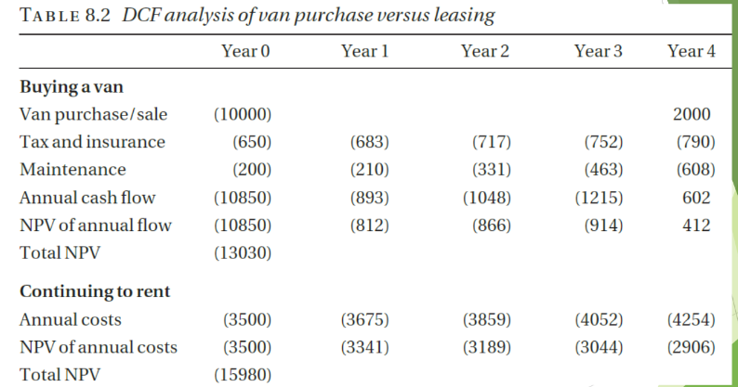

Buying Van
- Cost = £10,000.
- Annual costs: insurance, tax, maintenance.
- Resale after 5 years = £2,000.
- Discount rate = 10%.

Hiring Van
- £35 per day × 100 days = £3,500 per year.
- Subject to inflation.

Decision
- Calculate PV of both options using DCF.
- Choose lower present cost.
Example/Case:
- If PV of buying < PV of hiring → buy.

Software House Example
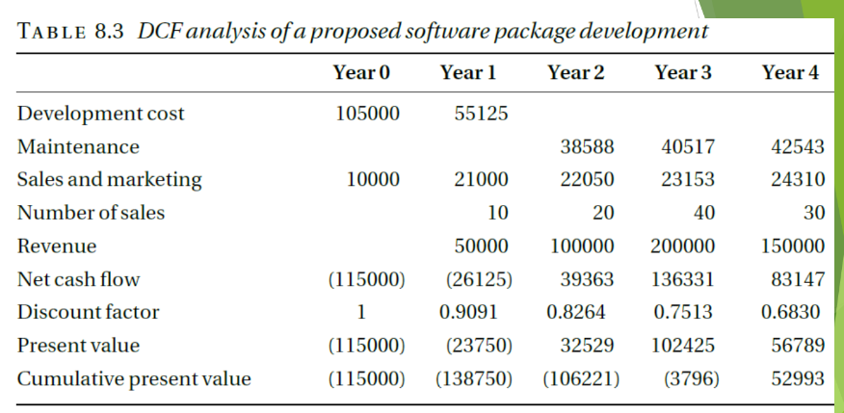

Costs
- Developers:
  - Year 1: 3 people
  - Year 2: 1.5 people
  - Cost per person = £35,000/year
- Maintenance after Year 2: 1 person full-time.
- Sales & marketing:
  - £10,000 in Year 1
  - £20,000 in Years 2–5.

Income
- 100 copies × £5,000 = £500,000 over period.

Use DCF
- Discount all costs & revenues.
- Find NPV.
Example/Case:
- If NPV positive → financially attractive.

NPV and IRR
- NPV (Net Present Value):
  - Sum of all discounted cash flows.
  - NPV > 0 → accept project.
- IRR (Internal Rate of Return):
  - Interest rate where NPV = 0.
  - Higher IRR → better return.

Pitfalls of DCF (Especially for Software)
Even if NPV = £52,993 and IRR = 23% look good:

Risks
- Software often takes more effort than expected.
- Initial versions may not work well.
- Sales may be lower than forecast.
- Competitors may launch earlier.

Best Practice
- Run DCF with different assumptions.
- Do sensitivity analysis.
Example/Case:
- Try best-case, worst-case, and likely-case cash flows to see impact on NPV.

Chapter 8: Solved Numericals
NPV,Depreciation, Payback Period
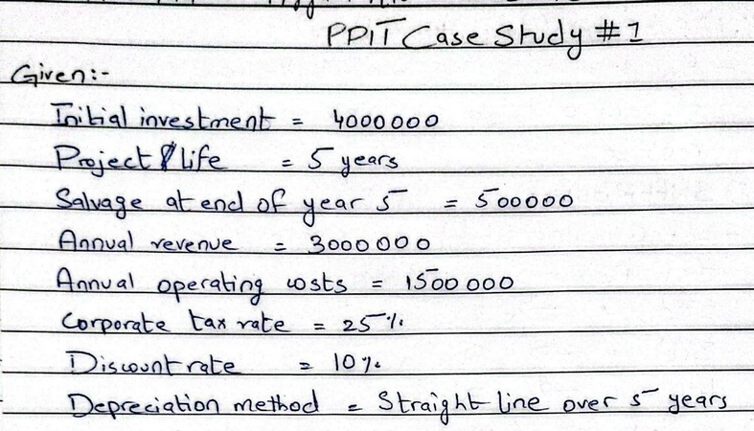
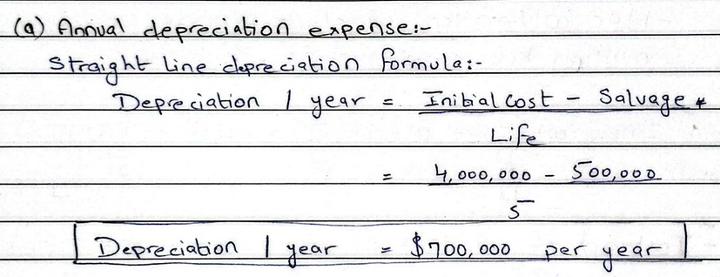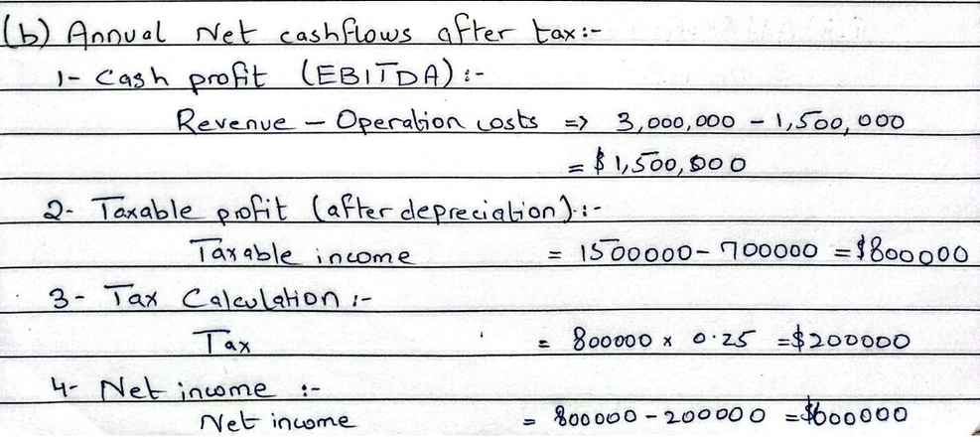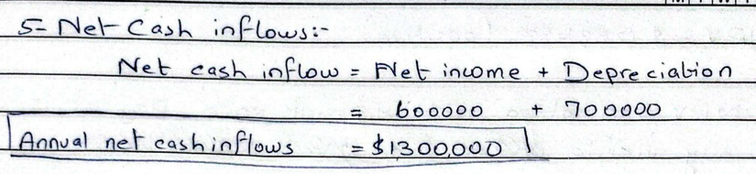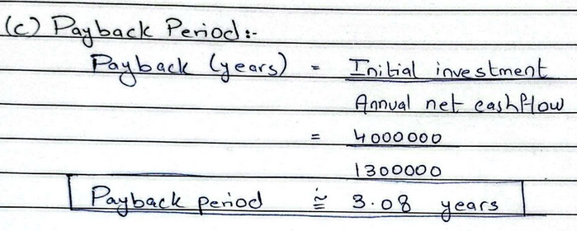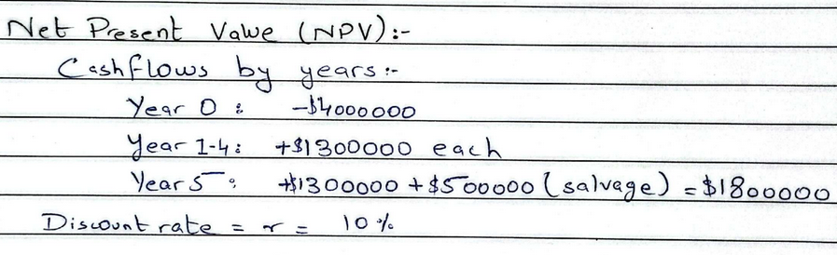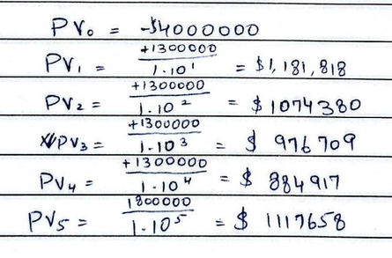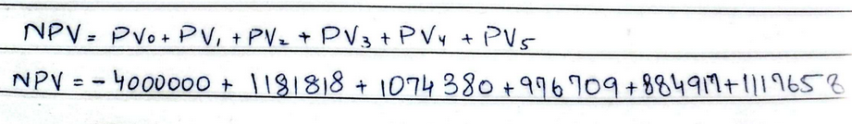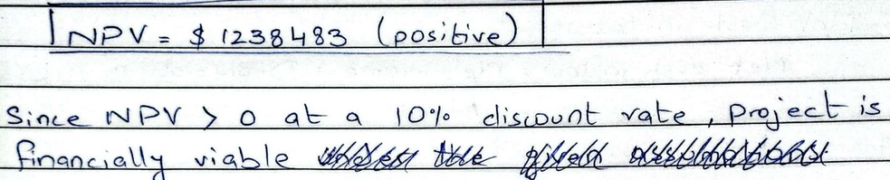

Chapter 8: Mid 2 Solved Numerical Of Purchase vs Lease


